

Department | FED
Subject | DSA-2
Academic Year | I-III Semester(2025-26)
Faculty Name | Gopi Krishna
Student Name | V Sri Bhargavi
Roll Number | 2520040048
Branch | ECE
Course Outcome | 1

Case Study Topic: Movie Popularity Ranking using Sorting Algorithms

Work Done Summary:

In this case study, we ranked movies by their popularity using sorting algorithms. View counts were stored for each movie, and a comparator-based sorting method was applied to order movies in descending popularity. The goal was to demonstrate efficiency and clarity achieved through sorting.

Implementation Details:
- Created a Movie class containing movie name and view count.
- Inserted multiple movie entries into an ArrayList.
- Applied Collections.sort() using a custom comparator.
- Printed movies in descending order of views.
- compared sorted and unsorted datasets for clarity.
- Verified time complexity O(n log n) for sorting operations.
Result: Screenshots :
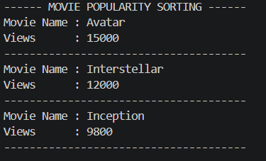
Sorting was used to rank movies by viewer count in descending popularity.
The top-ranked movies were:
Avatar (15000 views), Interstellar (12000 views), Inception (9800 views)
Time Complexity:
• Sorting (Arrays/Collections): O(n log n)

GitHub Link: https://github.com/sribhargavivaddavalli-svg/DSA_CASESTUDIES

